Nama : Ilham Maulana Ramadhan

NIM : 1207070058

Matkul : Mobile Programing

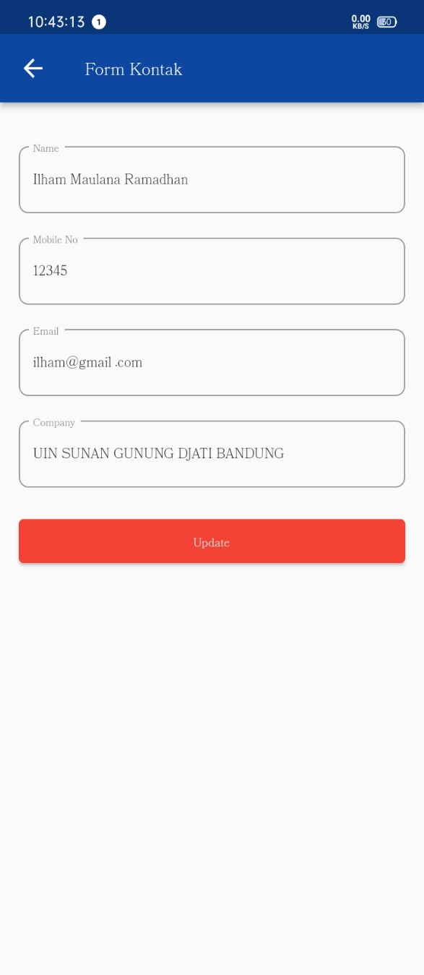 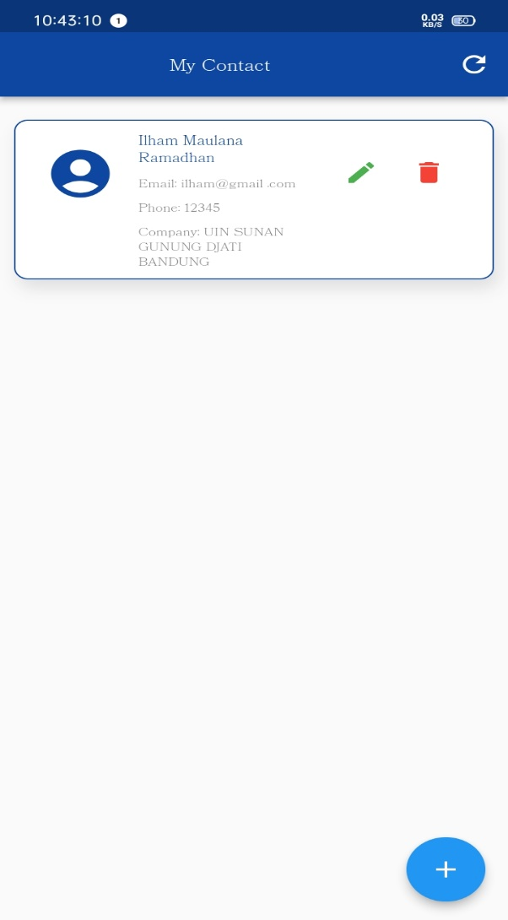

https://github.com/ilhamchuaks/1207070058_Ilham-Maulana-Ramadhan_Mobile.git